

**2nd TERM EXAM REVIEW**

| **GRAMMAR** |
| --- |
| * Comparatives and superlatives * Relative pronouns * Get/be used to/used to * Present simple, continuous and perfect * Past simple, continuous and perfect * Future simple (will, be going to, present simple, present continuous) |
| **VOCABULARY** |
| * Generations * Adverts * Future * Phrasal verbs |
| **WRITING** |
| * Review |
| **READING/LISTENING TOPICS** |
| * Generations * Adverts * Future * Digital era |



**COMPARATIVES and SUPERLATIVES**

| **COMPARATIVE** | **SUPERIORITY** | -er than | iOS is safer than Android |
| --- | --- | --- | --- |
|  |  |
| more than | Pablo is more intelligent than me |
| **EQUALITY** | as…as | My knowledge of Spanish is as good as yours. (Mi conocimiento de español es tan bueno como el tuyo) |
| **INFERIORITY** | less… than | My knowledge of French is less than yours. (Mi conocimiento de francés es menor que el tuyo) |
| **SUPERLATIVE** | **SUPERIORITY** | the -est | She is the smartest girl in the class. (Ella es la niña más inteligente de la clase). |
| the most | He is the most popular person in town. (Él es la persona más popular de la ciudad). |
| **INFERIORITY** | the least | She is the least prepared student in the exam. (Ella es el estudiante menos preparado para el examen). |

<https://test-english.com/grammar-points/b1/comparative-superlative-adjectives-adverbs/>

<https://test-english.com/grammar-points/b1/comparative-superlative-adjectives-adverbs/2/>

<https://test-english.com/grammar-points/b1/comparative-superlative-adjectives-adverbs/3/>

**RELATIVE PRONOUNS**

| **RELATIVE PRONOUN** | **It refers to…** |
| --- | --- |
| **WHAT** | What are you doing? (¿Qué estás haciendo?) |
| **WHICH** | Which book do you like the most? (¿Qué libro te gusta más?) |
| **WHERE** | Where do you live? (¿Dónde vives?) |
| **WHEN** | When did you last see her? (¿Cuándo la viste por última vez?) |
| **WHO** | Who gave you that? (¿Quién te dio eso?) |
| **WHOSE** | Whose car is that? (¿De quién es ese auto?) |
| **WHY** | Why did you do that? (¿Por qué hiciste eso?) |

1. Combine the following sentences using a relative pronoun:
2. Jessica has got a coin collection. It contains many rare coins.
3. Zedco has 10,000 employees. It’s an international company.
4. Mary spent the money. It belonged to her sister.
5. The pen is on the desk. It is blue.
6. This is the new president. We all voted for him.
7. I met a Finnish tourist. He lives in Helsinki.
8. I know the man. He is going to marry my friend.
9. John bought a new DVD player. It was made in Korea.
10. The palace stands outside the town. It was built 200 years ago.
11. They visited the village. It is on a hill.
12. The book is about a lawyer. He is accused of murder.
13. Tim will never forget that day. He joined the army that day.
14. We heard the song. It shocked many people.
15. The teacher apologized. She had punished two pupils unfairly.
16. I met a friend last week. Her daughter is an astrologist.
17. Tom hired a decorator. The decorator is very expensive.
18. This is the house. Jean lived in that house when she was young.
19. We saw the cottage. Wordsworth lived there.
20. Jessica has got a coin collection which contains many rare coins.
21. Zedco, which is an international company, has 10,000 employees.
22. Mary spent the money that belonged to her sister.
23. The pen, which is blue, is on the desk.
24. This is the new president who we all voted for.
25. I met a Finnish tourist who lives in Helsinki.
26. I know the man who is going to marry my friend.
27. John bought a new DVD player which was made in Korea.
28. The palace, which was built 200 years ago, stands outside the town.
29. They visited the village which is on the hills.
30. The book is about a lawyer who is accused of murder.
31. Tim will never forget that day when joined the army that day.
32. We heard the song which shocked many people.
33. The teacher who had punished two pupils unfairly apologized.
34. I met a friend whose daughter is an astrologist last week.
35. Tom hired a decorator who is very expensive.
36. This is the house where Jean lived when she was young.
37. We saw the cottage where Wordsworth lived.

<https://test-english.com/grammar-points/b2/relative-clauses/>

<https://test-english.com/grammar-points/b2/relative-clauses/2/>

<https://test-english.com/grammar-points/b2/relative-clauses/3/>

<https://test-english.com/grammar-points/b2/relative-clauses/4/>

**GET USED TO/BE USED TO/USE TO**

|  | **MEANING** | **EXAMPLE** |
| --- | --- | --- |
| **GET USED TO** |  |  |
| **BE USED TO** |  |  |
| **USE TO** |  |  |

1. Rewrite the sentences **using get used to/be used to/use to** so they mean the same:
2. It was normal for me to watch TV three or four hours a day.
3. After some time living here, it will seem normal to you.
4. Danger is nothing unusual for soldiers
5. In the past, Tom was more reliable.
6. He often speaks in public.
7. Horror movies were not my cup of tea, but I like them now.
8. When I was young, climbing trees was my favorite pastime.
9. It was normal for me to watch TV three or four hours a day.

I was used to watching TV three or four hours a day.

1. After some time living here, it will seem normal to you.

I got used to it after some time living here.

1. Danger is nothing unusual for soldiers

Soldiers are used to danger.

1. In the past, Tom was more reliable.

Tom used to be more reliable.

1. He often speaks in public.

He is used to speaking in public.

1. Horror movies were not my cup of tea, but I like them now.

I got used to watching horror movies.

1. When I was young, climbing trees was my favorite pastime.

I used to climb trees when I was yong.

<https://test-english.com/grammar-points/b1-b2/used-to/>

<https://test-english.com/grammar-points/b1-b2/used-to/2/>

**PRESENT SIMPLE, CONTINUOUS and PERFECT**

|  | **USE** | **STRUCTURE** | **EXAMPLE** |
| --- | --- | --- | --- |
| **PRESENT SIMPLE** |  |  |  |
| **PRESENT CONTINUOUS** |  |  |  |
| **PRESENT PERFECT** |  |  |  |

1. Complete the following text with the correct option (**present simple, continuous or perfect**):

There are/are being over one billion Facebook users worldwide. And this number increases/is increasing all the time. It is clear that Facebook changes/has changed the way we look/have looked at friendship. The word “friend” becomes/has become a verb, and “friends” now include/have included people we only know/are knowing online and who we are never meeting/have never met. One positive side to Facebook is that friends who lose/have lost contact, often many years ago, are now able/have now been able to get in touch again. “More and more people connect/are connecting whit old friends via Facebook”, says a spoken person for the website. ”And Facebook also means/has meant that friends never need/have needed to lose touch; people stay friends for life”.

There are over one billion Facebook users worldwide. And this number increases all the time. It is clear that Facebook has changed the way we look at friendship. The word “friend” has become a verb, and “friends” now include people we only know online and who we have never met. One positive side to Facebook is that friends who have lost contact, often many years ago, are now able to get in touch again. “More and more people are connecting whit old friends via Facebook”, says a spoken person for the website. ”And Facebook also means that friends never need to lose touch; people stay friends for life”.

**PAST SIMPLE, CONTINUOUS and PERFECT**

|  | **USE** | **STRUCTURE** | **EXAMPLE** |
| --- | --- | --- | --- |
| **PAST SIMPLE** |  |  |  |
| **PAST CONTINUOUS** |  |  |  |
| **PAST PERFECT** |  |  |  |

1. Choose **past simple, continuous or perfect** to complete the sentences below:

<https://test-english.com/grammar-points/b1/past-simple-past-continuous-past-perfect/>

1. Choose the most suitable answer for each gap below:

<https://test-english.com/grammar-points/b1/past-simple-past-continuous-past-perfect/2/>

**FUTURE SIMPLE**

|  | **USE** | **EXAMPLE** |
| --- | --- | --- |
| **WILL/WON’T** |  |  |
| **BE GOING TO** |  |  |
| **PRESENT SIMPLE** |  |  |
| **PRESENT CONTINUOUS** |  |  |

1. Complete the following sentences with the correct form of “**THE FUTURE**”:
2. Are you still writing your essay? If you __________ (to finish) by 4pm, we can go for a walk.
3. I __________ (to see) my mother in April.
4. Look at the clouds – it __________ (to rain) in a few minutes.
5. You’re carrying too much. I __________ (to open) the door for you.
6. When I __________ (to see) you tomorrow, I __________ (show) you my new book.
7. After you __________ (to take) a nap, you __________ (to feel) a lot better
8. I __________ (to buy) the cigarettes from the corner shop when it __________ (to open).
9. Before we __________ (to start) our lesson, we __________ (to have) a review.
10. We __________ (to wait) in the shelter until the bus __________ (to come).
11. I’m very sorry Dr. Jones __________ (not be) back in the clinic until 2pm.
12. I don’t think you __________ (to have) any problems when you land in Boston.
13. In three years I __________ (to live) in a different country.
14. __________ (to take) your children with you to France?
15. Now I __________ (to check) my answers.
16. They ________ (drive) to New York tomorrow morning. I hope the weather _______ (be) nice.
17. I offered him this job. I think he _______ (take) it.
18. I promise I _________ (not tell) your secret to anyone.
19. Take your umbrella with you. It ________ (rain).
20. They _______ (play) cards this evening.
21. I ________ (go) to the cinema tomorrow.
22. They __________ (fly) to Seattle next summer holidays.
23. I _______ (invite) 50 people to the party, and I hope everyone __________ (come).
24. That exercise looks difficult. I ___________ (help) you.
25. _______ he ______ (go) to the football match?
26. Are you sure they ________ (win) the match?
27. She _____ probably ______ (stay) till Thursday.
28. He _________(not leave) tomorrow.
29. We think he __________ (come) home late in the night.
30. Are you still writing your essay? If you finish by 4pm, we can go for a walk
31. I am going to see my mother in April
32. Look at the clouds – it is going to rain in a few minutes.
33. You’re carrying too much. I will open the door for you.
34. When I see you tomorrow, I will show you my new book.
35. After you take a nap, you will feel a lot better.
36. I will buy the cigarettes from the corner shop when it opens.
37. Before we start our lesson, we are going to have a review.
38. We will wait in the shelter until the bus comes.
39. I’m very sorry Dr. Jones won’t back in the clinic until 2pm.
40. I don’t think you will have any problems when you land in Boston.
41. In three years, I am going to live in a different country.
42. Are you going to take your children with you to France?
43. Now I will check my answers.
44. They are driving (drive) to New York tomorrow morning. I hope the weather will be (be) nice.
45. I offered him this job. I think he will take (take) it.
46. I promise I won't tell (not tell) your secret to anyone.
47. Take your umbrella with you. It is going to rain (rain).
48. They are playing (play) cards this evening.
49. I am going (go) to the cinema tomorrow.
50. They are flying (fly) to Seattle next summer holidays.
51. I am inviting (invite) 50 people to the party, and I hope everyone will come (come).
52. That exercise looks difficult. I will help (help) you.
53. Is he going (go) to the football match?
54. Are you sure they will win (win) the match?
55. She will probably stay (stay) till Thursday.
56. He is not leaving (not leave) tomorrow
57. We think he will come (come) home late in the night.
58. Choose the correct verb to complete the sentences:
59. ‘How often _________ running?’ ‘Twice a week, usually.’
    1. are you going
    2. do you go
    3. will you go
60. ‘Is the café open today?’ ‘Yes, but it _________ at all on Sundays.’
    1. isn’t opening
    2. doesn’t open
    3. won’t open
61. Don’t be late tomorrow – the bus _________ at nine o’clock.
    1. will leave
    2. is going to leave
    3. leaves
62. Let’s go for another swim after we _________ this drink.
    1. are going to finish
    2. finish
    3. will finish
63. ___ anything interesting at the moment?
    1. Are you reading
    2. Will you read
    3. Are you going to read
64. You look cold. I _________ you hat to wear.
    1. ‘ll give
    2. ‘m giving
    3. ‘m going to give
65. I’m so excited! My favourite singer _________ here in June.
    1. plays
    2. will play
    3. is playing
66. Be careful! That ladder isn’t safe – you _________!
    1. are falling
    2. are going to fall
    3. fall

Ab

Bc

Cc

Db

Ea

Fa

Ga

Hb



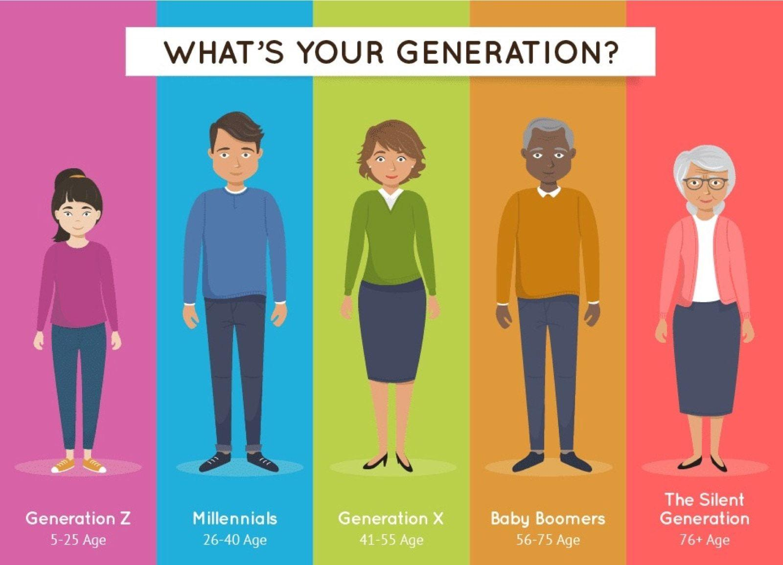

| Log in  Sign in |  |
| --- | --- |
| Sign up |  |
| Hook up |  |
| Power up  Turn on  Boot up  Start up |  |
| Set up |  |
| Pull down |  |
| Click on |  |
| Scroll down  Scroll up |  |
| Run out of |  |
| Print out |  |
| Back up |  |
| Hack into |  |
| Go down |  |
| Wipe out |  |
| Pop up |  |
| Plug in |  |
| Key in |  |
| Filter out |  |
| Turn off  Shut down  Power down |  |
| Go online |  |



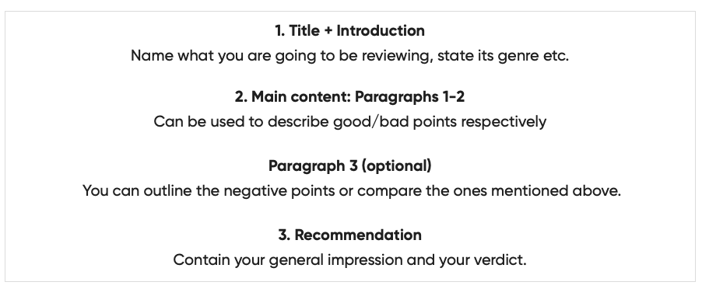

**Useful expressions**

| **OPINION** | I was pleasantly surprised by ...  I was disappointed with / by  The only criticism I would make is that …  What I really loved about … is …  It's certainly at the top of my list  To me, … seemed …  On the one hand / on the other hand,  On the plus side / on the negative side,  Despite the fact that ...  First of all, / to begin with / last but not least  in short / to sum up / in conclusion |
| --- | --- |
| **MAKING A RECOMMENDATION** | Iwould highly / strongly recommend ...  I certainly wouldn’t recommend …  I strongly advise you (not) to …   … is not to be missed!  Don’t bother buying …  I would strongly encourage you not to waste your money on ... |